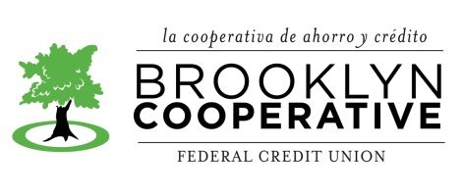
POSITION TITLE: Part Time Teller/Member Service Representative
FLSA: non-exempt

ORGANIZATION DESCRIPTION
Brooklyn Cooperative Federal Credit Union is a not-for-profit, member-owned financial institution with about 6,000 members and over $18 million in assets. We serve two neighborhoods, Bushwick and Bedford Stuyvesant, each among the most under-banked neighborhoods in New York City. The credit union provides fair and affordable financial services, including saving, checking, and ATM accounts, and consumer, business, and housing loans.

POSITION SUMMARY: A Member Services Representative (MSR) is a key position at the credit union. He or she is often the first point of contact for people coming to the credit union to learn about what we do, to open an account, or with questions or concerns regarding their existing account. All MSRs also act as Tellers, responsible for executing day to day monetary transactions. The best person for this position will be a pro-active, diligent, reliable, and friendly team member willing to support the organization as outlined below and in ways that will evolve over time.

ESSENTIAL JOB FUNCTIONS
- Promptly respond to all member inquiries and requests
- Post and reconcile daily credit union electronic files as needed
- Execute member transactions accurately, with daily reconciliation of cash and checks
- Compliance with federal regulations regarding CTRs, SARs, and OFAC
- Exercise strict adherence to security, operating, and compliance policies
- Complete projects assigned by branch and organizational managers in a timely fashion
- Promote the credit union’s diverse programs within the membership
- Performs other duties as assigned.

EXPERIENCE and EDUCATIONAL REQUIREMENTS:
Two years of cash-handling experience
High School degree or higher

SKILL REQUIREMENTS:
- Language: fluency in at least English and Spanish
- Accuracy and attention to detail
- Solving problems and determining solutions
- PC skills; Microsoft Office applications (Word, Excel); and other applicable applications
- Communicating with co-workers to provide and receive direction

WORK ENVIRONMENT:
Professional office environment

PHYSICAL REQUIREMENTS:
Positions in this class typically require: standing, walking, typing, grasping, talking, hearing, seeing and repetitive motions. Low-intensity work: exerting no more than 20 pounds of force occasionally to move objects

SALARY AND BENEFITS:
The credit union offers paid vacation and sick days, a 401K plan including employer match, and subsidized health care benefits. Salary is $12 per hour.

TO APPLY:
Please submit resume and cover letter to:
Rebecca Pear, Director of Member Services
e-mail: rebecca@brooklyn.coop

Date: 1/2017

