Invoice |  | Date:
Brooklyn Coop Federal Credit Union  Tax Services  1474 Myrtle Avenue  Brooklyn, NY 11237  834 Dekalb Ave  Brooklyn, NY 11221  Phone: 718-418-8232 x2110  Fax: 718 -418-8252 718-488-7282  Email: tammy@brooklyn.coop | Client:
Payment Method
Qty | Description | Unit Price | Line Total
 | Form 1040 + 1 Schedule (net income under $25,000) | $75
 | Form 1040 + 1 Schedule (net income over $25,000) | $125
 | Each Additional State | $25
 | Each Additional Schedules A, C, D, or E | $30
 | Each Additional W2s or 1099-MISC (after 5) | $15
 | Partnership/Corp (1041, 1065, 1120, 1120S) | $200 and up
 | Fed and State extensions | $35
 | NYS Sales and Use Tax (per filing) | $35
 | NYS Sales and Use Tax online setup | $50
 | Estimated Tax: Fed and State | $50
 | Add'l tax return copy | $15
 | Form 1099 | $20
 | general tax assistance (form completion, IRS correspondence, etc) | $25/half hr

Thank you!

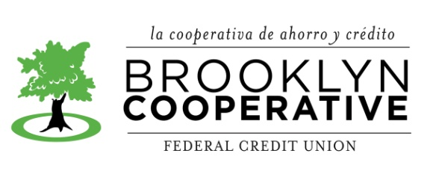
* In case of financial hardship, fees may be adjusted.

